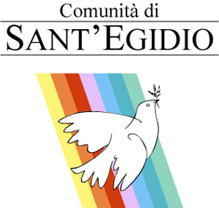 |  | 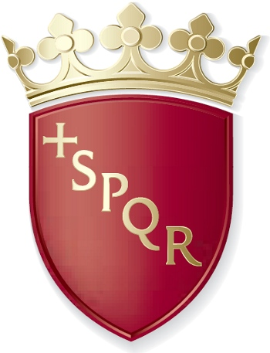  ROMA CAPITALE
Rome,…………………
Dear Sir,
Repudiation of the death penalty represents an important step in the direction of new worldwide conscience. Just as the world rejected slavery and torture, the same is happening today with capital punishment: once considered normal practice, the death penalty is today viewed as an unacceptable violation of human dignity.
In 2011 progress was made in all regions of the world, particularly the United States: Illinois became abolitionist and in April 2012 Connecticut became the 17th state to abolish the death penalty, thus becoming the fifth American state to revoke capital punishment in the last five years. In Asia, the Mongolian parliament approved adoption of the Second Optional Protocol of the International Treaty on Civil and Political Rights, promising the United Nations and the international community that it will not inflict to the death penalty anymore.
Even though the number of countries that no longer apply the death penalty either on a de jure or a de facto basis is increasing and the death penalty is widely perceived as a remnant of the past, it is still necessary to gather a broader consensus and an increasing commitment on the part of civil society.
Thus the Community of Sant’Egidio created the International Day of Cities for Life-Cities against the Death Penalty, which falls every year on November 30, anniversary of the first official abolition of the death penalty on the part of a State, enacted by the Grand Duchy of Tuscany in 1786.
Since 2002 over 65 capitals and 1,465 cities have joined, situated in 87 countries, some of which still apply the death penalty: an important occasion for raising awareness and involving institutions in the quest for a judicial system that respects life.
Preparations are currently underway for the eleventh edition of the International Day of Cities for Life-Cities against the Death Penalty to be held on November 30, 2012. We would thereby appreciate your city’s participation in the numerous events being organized to mobilize public in conjunction with the Community of Sant’Egidio and the World Coalition against the Death Penalty in Italy and other countries.
Participation is quite easy: each city dedicates a monument or a square to the initiative, a symbolic place that will be lit up on November 30 like the Coliseum in Rome. The site will be the moral and material centre of events, announcements and other initiatives in the city connected with the rest of the world. The city will appoint a representative to serve as a contact with the Organization of the Movement of Cities for Life to coordinate awareness-raising initiatives and launch an effective information campaign (press conferences, statements or messages from the City Council or the mayor on the day of the event, museum events in the cities of art, concerts, video and radio statements by testimonials representative of the city and of the country, assemblies in schools and universities) for the purpose of reaching he highest number of people, locally and in the world.
Your city will thus be included in an Honour List of cities involved in this struggle for civilization: “Cities for Life – Cities against the Death Penalty”.
All “Cities for Life” will be listed on a special page of our website (www.citiesforlife.net) with links to participating cities as well as on the site of the World Coalition against the Death Penalty (www.worldcoalition.org). It would therefore be very effective if the logo of “Cities for Life”, with a link to the web page of the initiative, appeared in your city’s home page and if your administration would ask the local media to do likewise in support of the World Campaign.
Attached please find a note on procedures for joining, while we ask that you confirm receipt of this letter by July 31, 2012.
In order to best prepare for the initiatives and international coordination and give visibility to your city, it would be desirable that participation and plans be arranged no later than September 30, 2012.
We would appreciate it if you could suggest other cities you believe might be interested in the event as well as the names of political, cultural or show business figures willing to serve as spokesmen.
Looking forward to a prompt reply, we take this opportunity to extend our high esteem.
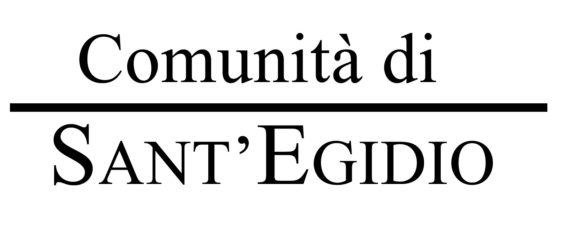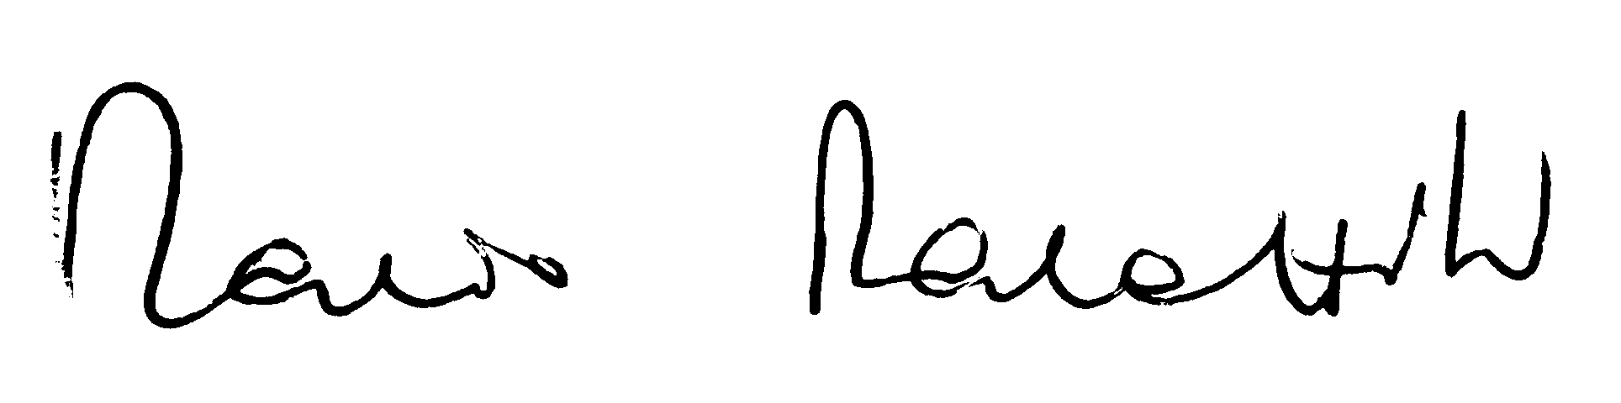
Contacts and further information:
Leonardo Tranggono
Comunità di Sant’Egidio - Piazza di S. Egidio 3/A - 00153 Roma, Italia
www.santegidio.org tel +39.06.585661 – fax +39.06.5883625
Email abolition@santegidio.org
info@citiesforlife.net
With the contribution of |   COMMISSIONE EUROPEA

Cities For Life - Cities Against the Death Penalty
ATTACHMENT 1

How to join

the Global Campaign

“Cities for Life – Cities against the Death Penalty”
(And samples of pro-active initiatives to be taken by each city who wants to join the Campaign)

- TO GIVE CONSENT TO ADVERTISE YOUR CITY AS A MEMBER OF THE CITIES FOR LIFE – CITIES AGAINST THE DEATH PENALTY, WITHOUT ANY BURDEN, IF NOT A MORAL OBLIGATION TO AGREE WITH THE CONTENTS AND INTENTION OF THE CAMPAIGN.
- TO DESIGNATE A SPECIAL MONUMENT, IDENTIFIABLE WITH THE “SOUL” AND IDENTITY OF THE CITY, AS THE LIVING LOGO OF THE CAMPAIGN, DECIDING A SPECIAL WAY TO LIGHT IT UP: BY SWITCHING FROM THE USUAL LIGHT STYLE TO A NEW ONE, EXPRESSING THE POSITIVE CHOICE FOR HUMAN RIGHTS OF YOUR CITY, OR PROJECTING ON IT SPECIAL SYMBOLS AND NESSAGES, ON NOV 30th EACH YEAR AND APPROACHING THAT DATE.

- following this, and as aDDITIONAL ACTIONS, SOME AMONG THE FOLLOWING AND OTHERS CAN BE TAKEN, IN COLLABORATION WITH THE COMMUNITY OF SANT’EGIDIO AND THE INTERNATIONAL NGOs – MOSTLY MEMBERS OF THE WCADP - THAT PROMOTE IN YOUR CITY THE CAMPAIGN:

- Designate a person, an office, that will become the contact of the Community of Sant’Egidio and the promoters for all initiatives relating to the Global Campaign.

- Join, with a resolution of the city council and by means of the individual signatures of the representatives the Appeal for a universal moratorium.

- The monument, building or place of major significance in your city, chosen for the purpose of illumination or decoration from 28 to 30 November 2010, will become significant also on other occasions connected to the defeat of the death penalty (e.g.: a state that abolishes the death penalty, or establishes a moratorium on executions or even commutes massive numbers of death penalty sentences…).

- Every city has the authority to declare November 30 as “Day for life/against the death penalty”, and, if it so wishes, can place the phrase” “City member of “Cities for Life/Cities against the Death Penalty” beneath the name of the city or its symbols and on its website and on any statement or stationery or means it may choose (a communication of the decision is to be shared with the promoters of the Campaign so as to advertise it in proper way as “good news”).

- Every city can link the home page of its website by means of a link to the website of the Community of Sant'Egidio (www.santegidio.org) which links up directly with the page of the Global campaign against the Death Penalty, www.santegidio.org/pdm/logo_cities.htm. A link will also be with www.worldcoalition.org.

This page contains the complete list of all the cities that have joined the campaign. Besides, it is appropriate that every city that joins this campaign should endeavour to advertise its support of the campaign in the local press.

Pictures or short videos of the events around the logo-monument of the campaign will be provided by the city to the home-website of the campaign, starting from Nov 29th each year, in order to create a “catalogue” of the world campaign available by Nov. 30th each year and for the whole year.

- Every city can invite citizens to sign the Appeal for the General Moratorium on executions with a view to the final abolition of the death penalty, by means of a communication campaign and a choice of several places, such as public buildings and museums, where it will be possible to sign a copy of the appeal. The text of the Appeal is provided by the Community of Sant’Egidio and it is also available for signatures online.

- Every city is encouraged to undertake cultural, public initiatives to raise public awareness (that could be supported and organised in conjunction with the Community of Sant’Egidio, its associates, and co-promoters from the World Coalition Against the Death Penalty, worldwide.

- Every city can “adopt” someone who has been condemned to death , through schools, the youth, taking all the actions needed to get up to a more just trial in case of lack of defence, and in any case to save the life of the person sentenced to death (publicity if it is appropriate for the case, correspondence, visits, legal defence, moral and practical support, public demonstrations...).

- Every city that so wishes can participate in the International Fund for the legal defence of those condemned to death, already created by the Community of Sant’Egidio. The entrance fee is 10 euros, 12 usd, 9 bp. Every city has the possibility to approve every year – but it is not bound to do it – any additional amount to increase and refill the International Fund.

- Every city can advertise and encourage citizens to click on line for a 2 euros/ US dollars/British pounds contribution to the same Fund. The online link for credit card/Paypal donations is provided by the promoters of the campaign.

- Bigger events, concerts, that may included fund raising, advertising, sms/mobile phone donations to support the international movement against the death penalty are, of course, among the possibilities and strongly encouraged.

- Special initiatives that link “art cities” (such as Rome, Paris, Venice, Barcelona, but also smaller ones from Salzburg to Siena) can involve special communication on the Campaign on the tickets and advertising of exhibitions during the last week of November each year, and propose a “gift-matching” with the international tourists who would agree about participating with a one euro offer for the human rights campaign.

- Cities are not bound to deposit funds in order to join the campaign, exception for the 10 euros.

- Donations are used to guarantee the right to defence also for the most disadvantaged: it is a tool for a higher standard of international justice. Many of the capitals and cities of Europe have contributed, so far, to this fund. Donations are to be sent to:

Account no. 807040
Comunità di S.Egidio-ACAP Onlus IBAN: IT67D0760103200000000807040
SWIFT/BIC code : BPPIITRRXXX
Reason for payment:
International Defence Fund for Death Row prisoners.

Contact for any question on all the above:

Leonardo Tranggono
Email: abolition@santegidio.org
info@citiesforlife.net
Community of Sant’Egidio
Piazza di S.Egidio 3/A - 00153 Roma - Italia
www.santegidio.org
Tel +39 - 06 -585661 – Fax +39 – 06 -5883625

