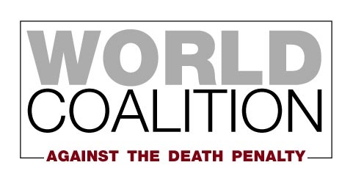

**Membership Application Form**

|  |  |
| --- | --- |
| **Organization** |  |
| **Legal status** |  |
| **Date of registration** |  |
| **Representative’s last name (capitalized)** |  |
| **First name** |  |
| **Position/profession** |  |
| **Address of the organization** |  |
| **Postal code** |  |
| **City/Town** |  |
| **Country** |  |
| **Phone** |  |
| **Fax** |  |
| **Email** |  |
| **Website** |  |
| **Facebook page or group** |  |
| **Twitter** |  |
| **Skype ID** |  |
| **Other social media** |  |

Information contact

**Your organization**

Mission and goals:

|  |
| --- |
|  |

Board members:

|  |
| --- |
|  |

How many employees/volunteers/members does your organization have?

|  |
| --- |
|  |

**Your activities against the death penalty**

Activities and campaigns to abolish the death penalty:

*Please describe in detail (a) any activities related to the death penalty that your organization has conducted over the last 3 years, and (b) any activities related to the death penalty that your organization plans to conduct in the next three years****. Please note that applicants that have not previously engaged in abolitionist activities will not be considered for membership****. If your organization has not yet engaged in any abolitionist activities, we encourage you to wait to apply until you can show that you have done so.*

|  |
| --- |
|  |

Does your organization oppose the death penalty in all circumstances? If no, please explain:

|  |
| --- |
|  |

What sources of funding does your organization have for its abolitionist work – private or institutional?

|  |
| --- |
|  |

Publications on the death penalty – yours or publications you contributed to. If available online, please include the link:

|  |
| --- |
|  |

Does your organization belong to an abolitionist network? If yes, please indicate which one:

|  |
| --- |
|  |

Does your organization collaborate with any organizations that are members of the Coalition? If yes, please specify:

|  |
| --- |
|  |

Does your organization have consultative status with an international organization? If yes, please indicate which one:

|  |
| --- |
|  |

How did you hear about the World Coalition Against the Death Penalty?

|  |
| --- |
|  |

**If you are attaching additional documents to this form, please describe them here:**

|  |
| --- |
|  |

**Please send the completed form to:**

Carlos Valera

World Coalition Against the Death Penalty

Mundo-M 🞄 47, avenue Pasteur  
93100 Montreuil, France

Fax : +33 1 48 70 22 25  
[cvalera@worldcoalition.org](mailto:cvalera@worldcoalition.org)