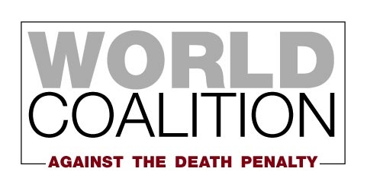

Membership Application Form
Organization
Legal status
Date of registration
Representative’s last name (capitalized)
First name
Position/profession
Address of the organization
Postal code
City/Town
Country
Phone
Fax
Email
Website
Facebook page or group
Twitter
Skype ID
Other social media

Information contact
Your organization

Mission and goals:

Board members:

How many employees/volunteers/members does your organization have?

Your activities against the death penalty

Activities and campaigns to abolish the death penalty:
Please describe in detail (a) any activities related to the death penalty that your organization has conducted over the last 3 years, and (b) any activities related to the death penalty that your organization plans to conduct in the next three years. Please note that applicants that have not previously engaged in abolitionist activities will not be considered for membership. If your organization has not yet engaged in any abolitionist activities, we encourage you to wait to apply until you can show that you have done so.

Does your organization oppose the death penalty in all circumstances? If no, please explain:

What sources of funding does your organization have for its abolitionist work – private or institutional?

Publications on the death penalty – yours or publications you contributed to. If available online, please include the link:

Does your organization belong to an abolitionist network? If yes, please indicate which one:

Does your organization collaborate with any organizations that are members of the Coalition? If yes, please specify:

Does your organization have consultative status with an international organization? If yes, please indicate which one:

How did you hear about the World Coalition Against the Death Penalty?

If you are attaching additional documents to this form, please describe them here:

Please send the completed form to:
World Coalition Against the Death Penalty
Mundo-M  47, avenue Pasteur
93100 Montreuil, France
or at :
join@worldcoalition.org

